Q1. How to resolve a clogged nozzle?
Method 1: Tap [Preheat], heat up the extruder to 200℃, after the device has heated, press the bowden quick coupler and pull out the bowden tube. Check to see whether the filament is bent, or filament tip is not smooth, cut filament tip smooth and flat. Reinstall the bowden tube and reload the filament by tapping [Load] and following the prompts.
Method 2: If method 1 has not resolved the issue, use the supplied unclogging pin tool to unclog filament.
Method 3: If method 1 and method 2 have not resolved the issue, a replace nozzle may be required.

Q2. How to replace the nozzle?
Ensure your nozzle is cool before removing! Power off before replacing nozzle! Make sure power off operation!
- Unload the filament from your print maker by tapping [Filament] and [Change] and follow the prompts provided.
- Allow your nozzle to cool fully before proceeding.
- Press the left and right clips of the extruder and pull down on the nozzle.
- Press the left and right clips, install the new nozzle back into the extruder, making sure the nozzle slot and bottom of extruder are on the same level.
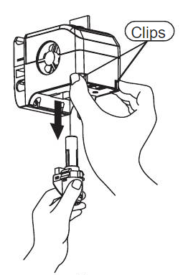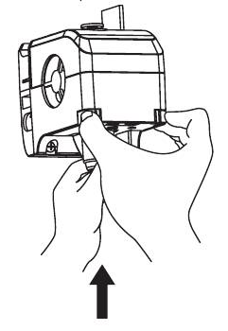

Q3. Abnormal temperature display after replacing nozzle?
Abnormal temperature indicates extruder sensor cannot be read correctly, please check the nozzle is well seated in the extruder by uninstalling and reinstalling.

Q4. No filament being extruded when build has begun?
- Check the bowden tube to make sure filament has been pushed all the way into the extruder.
- If yes, check the nozzle for a clog. Please refer to Q1 for resolution.
- If not, cancel your build and tap [Load] and follow the prompt. Ensure the filament has begun to come out of the nozzle before printing.
- Restart build by tapping [Build].

Q5. How to replace the filament?
- Tap [Filament], Tap [Replace], the printer will now begin the heating process.
- Filament will be unloaded automatically when heating has been completed.
- Pull out the filament according to the on-screen prompts.
- Insert new filament into the filament intake and feeding wheel, tap [OK].
- New filament will be pushed into the extruder (this may take a few minutes)
- Ensure the filament has begun to come out of the nozzle before printing.

Q6. Nozzle is too far/close to the print bed?
- Tap [Setting], tap [Calibration].
- The extruder will begin homing automatically.
- Tap up and down arrow to adjust the distance between extruder and platform until extruder is just about to touch platform.
- Tap [OK]. The printer will now memorize current calibration position and start homing automatically.

Q7. What kinds of file formats does the Print Maker support?
Input: 3mf / stl / obj / fpp / bmp / png / jpg / jpeg files.
Output: gx/g files.

Q8. How to solve the printed file has a warped edge?
Method 1: Heating up the platform can solve or minimize the problem by increasing adhesion between platform and model.
Method 2: Adding raft to model when slicing your file.
Method 3: Apply painters tape/glue to platform before printing.

Q9. After replacing the nozzle, printer status displays extruder temperature is 300°C?
The new nozzle may not be properly installed.
Abnormal temperature indicates extruder sensor cannot be read correctly, please check the nozzle is well seated in the extruder by uninstalling and reinstalling.

Q10. The extruder makes a noise and no filament come out of extruder?
Filament may not have been loaded into extruder correctly, the nozzle may be clogged or the bowden tube may not be properly installed. Check the bowden tube coupler first, if the guide tube is correctly installed, refer to Q1 for clogged nozzle or Q4 for filament not loaded into extruder.

Q11. What is the difference between filament load and filament replace?
Load: Process for only loading filament into extruder.
Replace: Process for unloading previous filament before loading new filament.

Q12. Print Maker cannot see a USB stick/flash drive?
Print Maker camera and USB port use the same interface. The camera and the USB port are incompatible and cannot be used at the same time. To use the USB port please make sure that the camera has been turned off.
See Print Maker camera user manual for more details (next page
Print Maker Camera User Manual

Note: Print Maker camera and USB port use the same interface. The camera and the USB port are incompatible and cannot be used at the same time. To use the USB port please make sure that the camera has been turned off.

Switching between camera and USB port can be done using either the PolarCloud
or on the printer’s LCD screen.

1. Switching between the camera and USB drive be controlled using the LCD screen

There are two modes that the camera can be in, they are, automatic mode (default mode) and manual mode.

The route to see what your Print Maker is in is (Tools->Settings (on the second page) -> Camera), click the Camera button to enter the relevant page.

Automatic mode: When the printer is printing, the camera is turned on and USB drive is turned off. When the printer is idling (not printing), the camera is turned off and USB drive is turned on (Picture 1).
Manual mode: The switching between camera and USB drive can be controlled by pressing either the camera icon or the USB icon depending on whether you are printing or not (Picture 2)

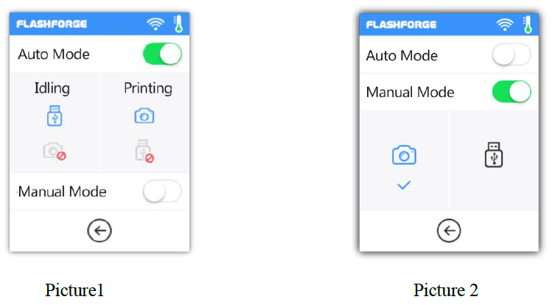

When the camera is turned on, a camera icon will appear in Status Bar (Picture 3). When the camera is turned off, a USB icon will appear in Status Bar (if the USB has been successfully loaded (Picture 4).)

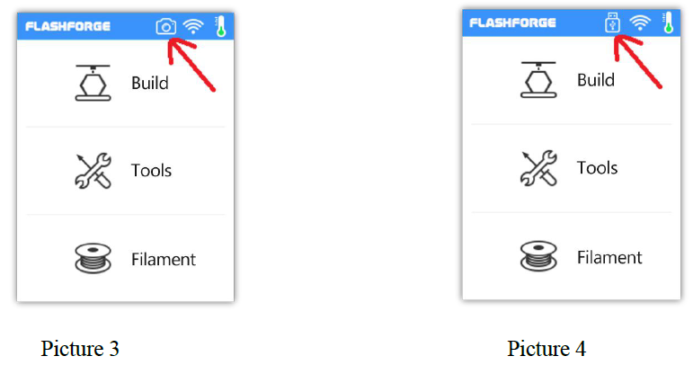

2. Switching between the camera and USB drive be controlled through the Cloud

(2.1) Connect to Polar Cloud

You can turn the camera on and off through Polar Cloud.

Click Tools-> Communication -> Cloud Connect -> Polar Cloud,
Enter the settings page of PolarCloud (Picture 6), enter your account number and PIN, then click the Start button.

.

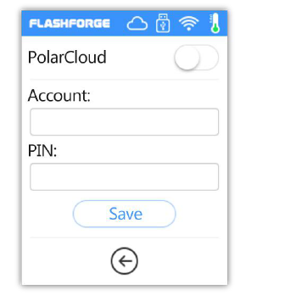
Picture 6

(2.22) Turn on the camera through the Cloud

Once you have successfully signed up with Polar Cloud, the logo of PolarCloud will appear in Status Bar on the LCD screen of your printer (Picture 7), at this moment, the camera can be seen through Polar Cloud (Picture 8) (if you are asked for a PIN this can be found in the “About” page (in the first page) of the printer (Picture 9).

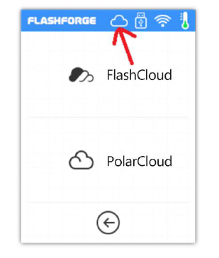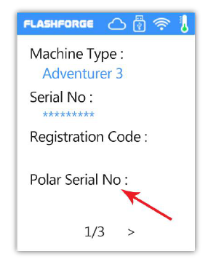
Picture 8 Picture 9

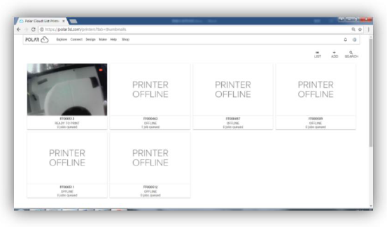Picture 9

Enter Polar Cloud, click the COMMANDS button in order to send the command to turn on or
turn off the camera (Picture 10 and Picture 11).
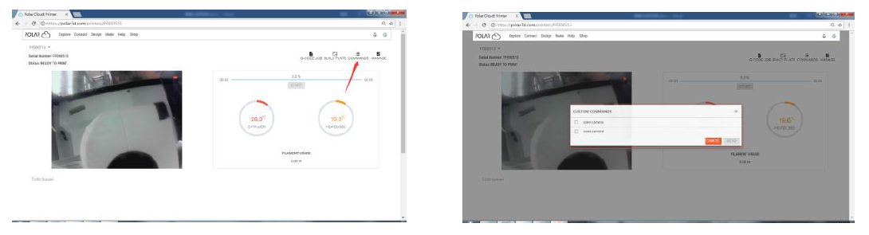
Picture 10 Picture 11

Turn on the camera through Polar Turn off the camera through Polar

Note: Polar Cloud is in an intranet (that is, the printer and PC connect to the same router), the video is shown, and the state of printing can be displayed in real time.

If Polar Cloud is in an extranet (that is, the printer and PC connect to different routers), the pictures are shown either every 20sec if printing and every 60sec if idling. If the camera is turned on or off, the LCD will turn off and reconnect Polar Cloud, so Polar Cloud will not respond for a while. The recovery time depends on the state of network.

After the camera is operated through the Cloud, the printer will set the camera to be in the manual mode; if the automatic mode is to be recovered, please set manually (Tools-> Settings (on the second page) -> Camera).

3. Viewing your camera through your PC

After the printer has connected to the network successfully and the camera is turned on.
Open the browser on PC or mobile photo and enter http://IPaddr:8080/?action=stream to browse the camera.

For example, if the printer’s IP address (the IP address is available on the “About” page of the printer)
is 10.33.23.78, the user can enter URL http://10.33.23.78:8080/?action=stream into
the browser, in order to check the quality of the camera.

Note: When the user wants to use the browser to view the images, the printer and PC
must be in an intranet (This can be done using PolarCloud).

4. Error handling
(1) When the camera is damaged or not inserted, the error is reported in case of
turning on the camera (Picture 13). At this point, the lower computer will
automatically set the camera to be in manual mode and the camera is turned off.

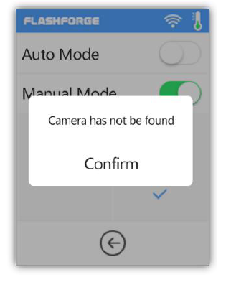
Picture 13

(2) If the lower computer does not connect to Polar Cloud and the printer is deleted
from the Cloud, the error is reported as shown in Picture 14; at this point, the
factory settings can be restored in order to solve the problem. After the lower
computer connects to the printer and the printer is deleted from the Cloud, the
sign-up needs to be done again according to the foresaid steps.

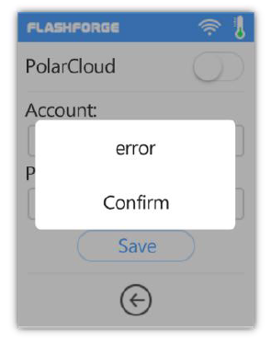
Picture 14

